NeuronForge Technologies
Q1: Ideation
PRD Genie — AI-Powered Product Documentation Assistant

Problem Statement
NeuronForge has identified a significant bottleneck in its product management process:
- PMs/TPMs spend a disproportionate amount of time gathering scope and requirements from meetings.
- Translating discussions into structured PRDs, epics, and user stories is highly manual and iterative.
- Different PMs/TPMs produce PRDs in different formats, making engineering estimation difficult.
- Meeting transcripts and notes sit in documents nobody revisits — valuable requirements get lost.
- This leads to delays, inconsistent tracking, and slower time-to-market.
PRD Genie is an AI-powered documentation assistant that ingests meeting transcripts, generates structured PRDs, and breaks them into epics and user stories — grounded entirely in what was actually said.

The Pitch, In Brief

The Problem: PMs are drowning in documentation, not doing product work
- Every sprint, PMs spend hours manually mining meeting transcripts for requirements.
- Every PM formats PRDs differently — engineering can't estimate consistently.
- Requirements sit buried in notes nobody revisits — until they resurface too late.
Result: delays, inconsistent tracking, slower time-to-market.

The Solution: from transcript to structured PRD, automatically
A multi-agent AI system that extracts requirements, generates a standardized PRD, and breaks it into epics and user stories — grounded entirely in what was actually said.
- Time back: hours reclaimed per sprint, redirected to product thinking.
- Consistency: every PRD follows one structure — apples-to-apples estimation.
- Traceability: nothing discussed gets lost or rediscovered three sprints later.
Validated against a 12-input baseline test suite — not just a demo.
Below is the high-level workflow of the TPMs where the agentic solution can resolve the issue of manual work and improve Productivity Accuracy and Consistency.
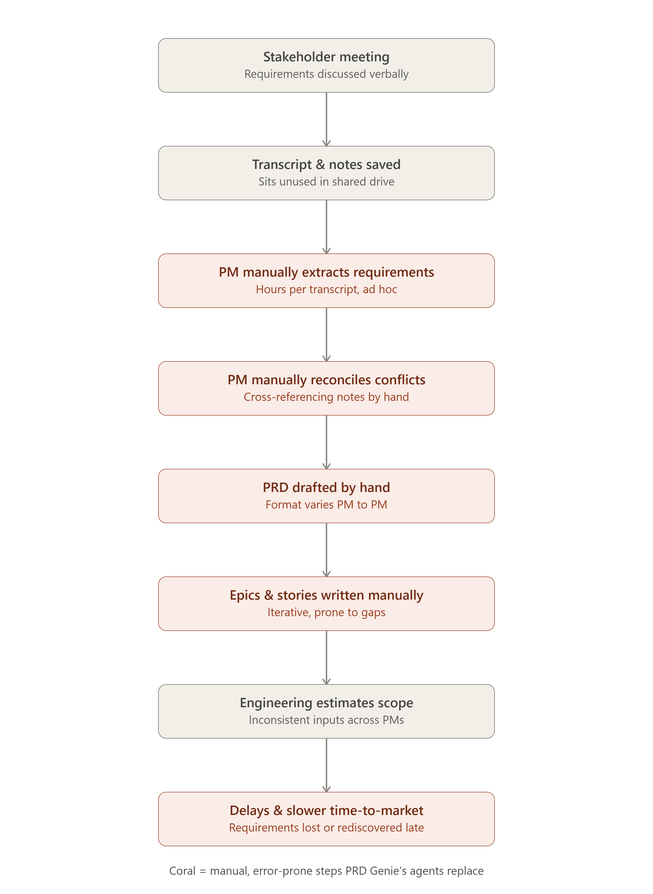  Before — Manual PM Workflow | 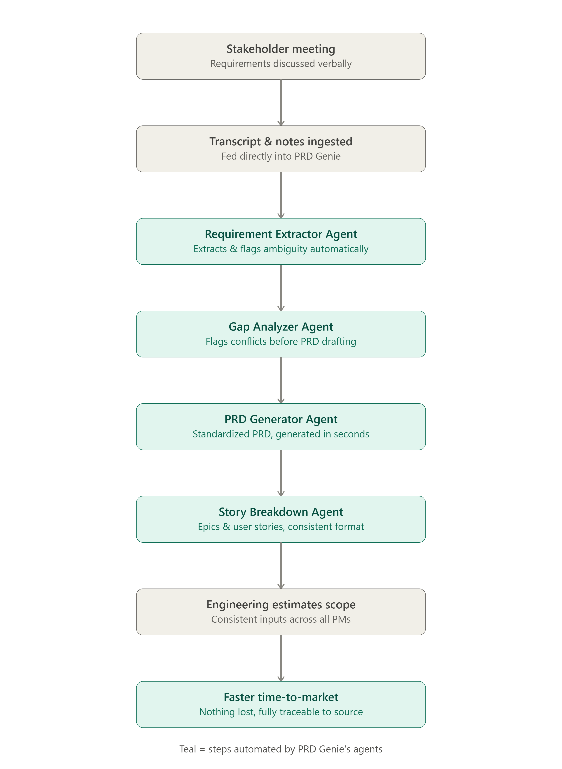  After — PRD Genie Pipeline

Pain Points → Agent Solutions
Each identified pain point maps to a dedicated agent with a single, clear responsibility — the same granularity that made this system easier to debug and evaluate during the build.
# | Pain Point | Manual Step Today | Agent Solution | Inputs → Outputs | Risks
1 | PMs spend disproportionate time gathering scope/requirements from meetings | PM manually re-reads/re-listens to meeting notes and transcripts to extract requirements | Requirement Extractor Agent  • Parses transcripts/notes across all provided documents  • Pulls out requirements, constraints, stakeholders, deadlines  • Flags ambiguous items rather than guessing | In:  • Raw transcript/notes (text), sourced via Google Drive so no document is missed  Out:  • Structured list of stated requirements + flagged ambiguities, traceable to source | May hallucinate requirements not actually stated; may miss implicit/contextual requirements a human would catch; may generate a contradictory requirement when synthesizing multiple transcripts, or bias toward one persona's viewpoint over another's.
2 | Identifying missing information and contradictions across multiple sources | PM has to manually cross-reference multiple meeting notes and transcripts to spot missing info or contradictions between versions | Gap Analyzer Agent  • Compares extracted requirements across all sources  • Identifies missing information and genuine cross-source conflicts  • Produces clarification questions for stakeholders — does not resolve them | In:  • Extracted requirements (structured JSON) from all sources  Out:  • List of insufficient/missing info; list of ambiguous or contradictory requirements | Over-flagging could create noise PMs start ignoring; may mislabel a genuine conflict as resolved (or vice-versa) if source wording is ambiguous.
3 | Translating discussions into structured PRDs, epics, and user stories is highly manual and iterative | PM manually structures the requirements into a PRD, then manually derives epics and user stories from it | PRD Generator Agent  • Takes extracted requirements + gap analysis  • Produces a structured PRD following a fixed template  • Preserves unresolved conflicts rather than silently picking a side | In:  • Extracted requirements + gap analysis report  Out:  • Well-structured PRD with accurate requirements, flagged assumptions and open questions | May misinterpret a requirement, drop coverage of a source, or (under strict output pressure) resolve a genuinely contested item as if it were settled.
4 | Difficulty in engineering estimation due to inconsistent PRD formats across PMs | Different PMs/TPMs produce PRDs in different formats and structures, making engineering estimation inconsistent | Shared PRD Template  • Every PRD is generated against one common template  • Template is supplied as a swappable input, not hard-coded into the agent's instructions, so it can be updated without a prompt change | In:  • PRD template  Out:  • Every PRD follows the same structure, enabling apples-to-apples estimation | If the template changes structurally (not just wording), the agent's output schema needs a matching update — template-following alone can't absorb a structural change automatically.
5 | Creating epics and user stories from a PRD is manual and iterative | PM manually converts the PRD into epics and user stories, assigning priority by hand | Story Breakdown Agent  • Converts PRD features into Epics, Features, and User Stories  • Separates stories by persona rather than merging them  • Inherits priority and preserves contested-item status from the PRD | In:  • Structured, finalized PRD  Out:  • User stories and epics with priority (Must / Should / Nice to Have) | Must reproduce acceptance criteria verbatim and not invent extra criteria; must not silently fill gaps with assumptions; may under-cover some requirements across a long, multi-part output.
Overall business impact: closing these five gaps directly targets NeuronForge's core symptom — delays, inconsistent tracking, and slower time-to-market — by replacing five manual, error-prone steps with grounded, traceable agent output

Additional Agents Introduced During the Build
Beyond the five core agents mapped above, three additional agents were introduced once implementation revealed that prompt-only self-verification has a ceiling — a model does not reliably audit its own long, multi-part output against a checklist within a single generation pass, no matter how the instruction is worded. These agents form a quality loop around PRD generation and story breakdown.

Agent | Purpose | Inputs → Outputs | Risk
Critique Agent | A single-pass review of the generated PRD against the extracted requirements and Gap Analysis report, checking for completeness, traceability, and grounding issues. | In: Generated PRD, Extracted Requirements, Gap Analysis report.  Out: A structured list of findings only — it does not rewrite the PRD itself. | Deliberately single-pass for cost and complexity reasons; some genuine issues may still go undetected or be inconsistently flagged.
Resolver Agent | Addresses the Critique Agent's findings without regenerating the PRD from scratch — a targeted patch, not a rewrite — which improves overall completeness and traceability. | In: Generated PRD, Extracted Requirements, Gap Analysis report, Critique report.  Out: A corrected PRD addressing the critique findings. | Runs 3 LLM calls per PRD instead of 1 (Generator + Critic + Resolver), on top of Extractor and Gap Analyzer upstream — a real cost/latency tradeoff.
Story Finalizer Agent | After Story Breakdown produces Epics, Features, and Acceptance Criteria, this agent patches in any Functional/Non-Functional Requirements a deterministic check found missing — without rewriting existing, correct stories. | In: Existing Story Breakdown, a deterministic validation report identifying missing FR/NFR IDs, and the finalized PRD as the authoritative source.  Out: A complete Story Breakdown containing the original content plus only the minimum changes required to close the gaps. | The final agent in the workflow — any hallucination introduced here has no downstream check. Requires strong guardrails to preserve grounding and traceability and avoid regressing already-correct stories.

Design Justifications

Multi-Agent vs. Single-Agent
Multiple agents have defined, granular responsibility, which makes the system easier to maintain and triage when something goes wrong — evaluation traces and logs can pinpoint exactly which agent produced an issue. Each agent can also be designed with guardrails specific to its role, reducing hallucination more effectively than one agent trying to do everything at once.

Google Drive as the Ingestion Source
Requirement extraction reads all provided documents directly from Google Drive rather than requiring a PM to paste content manually. This directly addresses the “documents sit unused” pain point — nothing gets missed simply because nobody thought to revisit it.

Why a Critique/Resolver Loop and a Story Finalizer, Despite the Added Cost
Lowering temperature helped reduce ungrounded, overly creative output across agents. But even after multiple passes, a clear pattern emerged: telling a model to “self-verify completeness” has a ceiling. The model does not reliably audit its own output against a full checklist within a single generation pass, regardless of how the instruction is worded — a real and repeatable limitation, not a one-off failure.
The additional agents (Critique, Resolver, Story Finalizer) exist specifically to overcome this incomplete self-auditing over a long, multi-part output. They add real cost — up to 3x the LLM calls for PRD generation alone — but that cost is a deliberate tradeoff for grounding and completeness, not an oversight. Where possible, a deterministic, code-based check (rather than another LLM pass) is used to catch what self-review alone could not.

